Free and featured this June at Cell Press

Filed to [Promoter](http://crosstalk.cell.com/blog/topic/promoter)

http://crosstalk.cell.com/hs-fs/hubfs/Headshots/meghan-gaucher.jpg?t=1478274396864&width=30&height=30&name=meghan-gaucher.jpg Posted by [Meghan Gaucher](http://crosstalk.cell.com/blog/author/meghan-gaucher) | Published June 29, 2016, 11:34

This month, Cell Press released free leading research from *Trends in Cell Biology*, *Current Biology*, and *Cell Metabolism* that provides a few clues to better understanding what the first eukaryote looked like, a previously unknown sampling of the oldest root system on earth, and a better understanding of the linking roles of neurons and the central nervous system in emergency response to stress.

All are available free of charge at [cell.com](http://www.cell.com/). Enjoy!

[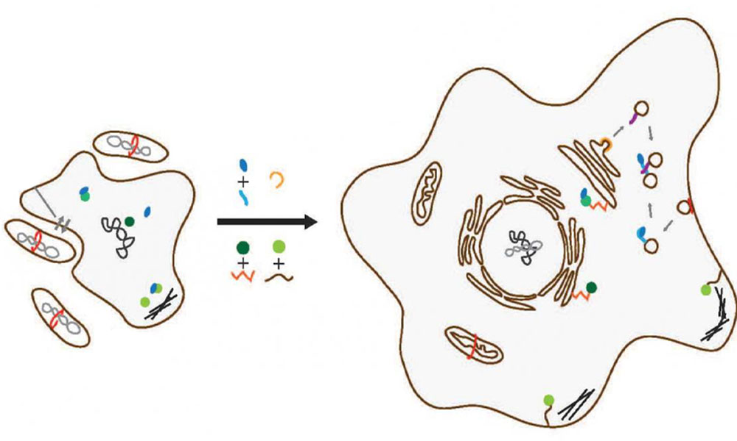](http://www.cell.com/trends/cell-biology/fulltext/S0962-8924(16)30002-2)

**An update on the marriage of two kingdoms: Archaea and bacteria**

Like any family tree, the genetic tree of living organisms looks simple at first glance. At the bottom, we have the roots, the prokaryotes that merged and created the things that make up our living kingdom today. Emerging from the roots we have the branches, the eukaryotes: plants, animals, fungi, and protists.

The defining feature of a eukaryote that sets it apart from other cell types is the single nucleus surrounded by other membrane-cushioned organs. Plant and animal cells are among the many types of eukaryotes that originated from the marriage of two prokaryote kingdoms: bacteria and archaea. It has been generally accepted by scientists that, when the two prokaryotes merged, the eukaryote materialized. However, there's been conflicting opinions about what the first eukaryote and its immediate ancestors looked like.

Things are more complicated than they appear. The "lost uncle" causal of discussion in the field of modern biology is the origins of the first eukaryote. As [Buzz Baum and his colleagues Mukund Thattai and Gautam Dey of University College London](http://www.ucl.ac.uk/lmcb/group-leaders) explain in [their Opinion paper published in *Trends in* *Cell Biology*](http://www.cell.com/trends/cell-biology/fulltext/S0962-8924(16)30002-2), the mystery has stemmed in large part from the lack of similarities between the interior complexity and large size of the eukaryotic cell and the simplicity of its prokaryotic origins.

Back to basics! The researchers studied the basic biology of DNA sequences from the organism Lokiarchaeum ("Loki" for short), the closest relative to the eukaryote, to try and answer the question of what the first eukaryote must have looked like. The researchers looked at eukaryotic signature proteins (ESPs) in the Loki and found that the ESPs must function differently than those in the eukaryote, because the Loki seemed to lack key ESPs associated with membrane-trafficking machinery.

Baum and colleagues discovered that the Loki could be modified for eukaryogenesis with the gain of key genes and lipids from a bacterial symbiont. The researchers predict that, when the Loki is isolated or cultured, the cellular structure appears more archaeal-like in structure. However, its cell cycle and development over time might have complexities more often associated with eukaryotes.

The researchers say they now plan to explore the basic cell biology of other closely related archaeons to the eukaryote in order to uncover other morphology complexities to better understand the makeup of the first eurkaryote.

[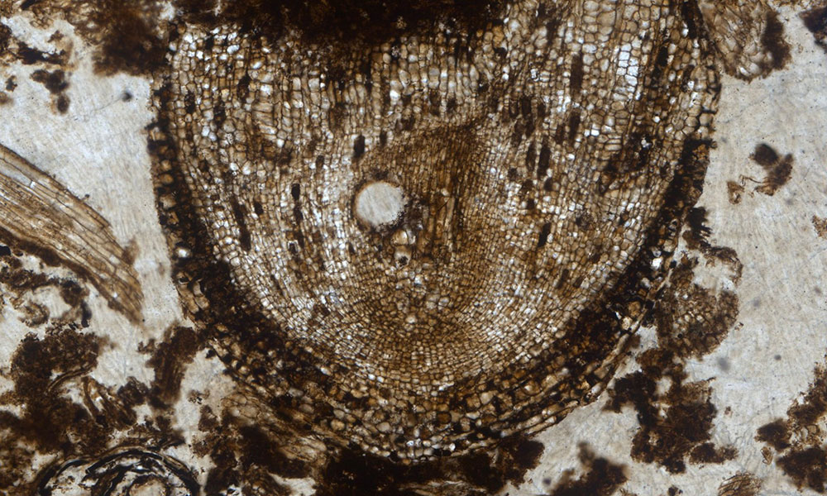](https://www.theguardian.com/science/2016/jun/22/fossil-plant-stem-cells#img-1)

**Frozen in time: A look at the oldest root systems known today**

A study published in *Current Biology* by Oxford Plant Sciences PhD student [Sandy Hetherington and colleagues](https://www.plants.ox.ac.uk/people)determines [the oldest known plant population within an *actively growing* fossilized root](http://www.cell.com/current-biology/fulltext/S0960-9822(16)30466-3) (also a surprising discovery!). Hetherington noticed the cellular structure during his lab work studying the root systems of ancient trees at the Oxford University Herbaria. A fossilized soil slide from the remains of the first giant tropical rainforests on Earth showed root tips that looked similar to those found in plant roots and shoots today. What Hetherington was actually observing were 320-million-year-old stem cells that were being preserved as they grew. The cellular pattern, unknown until now, gives scientists a rare opportunity to understand how the first root systems developed.

Stem cells are found at the tips of roots and shoots in trees and have a remarkable ability to develop into many different types of cells. The stem cells reproduce and form multicellular organisms, making them a valuable cell for studying root formation in plants and trees.

Hetherington has named the stem cell fossil *Radix carbonica* (Latin for "coal root"). Although stem cells are small and otherwise invisible to the naked eye, the stem cells found and studied can help us understand how the first ancient plant systems grew over time, which had a dramatic impact on the Earth's climate system; the evolution of deep rooting systems in ancient trees caused a chemical reaction in silicate rocks hundreds of millions of years ago. When chemical weathering in the rocks increased, CO2 was pulled out of the atmosphere, leading to a massive cooling of the earth's climate, one of the most significant ice ages in history.

The stem cells discovered are important because they demonstrate that both ancient and modern cellular structures found in plant roots have the same general dynamics, but the unique cellular structure found in the fossilized roots also represents a small sampling of the diversity that has existed since the roots first evolved long ago.

[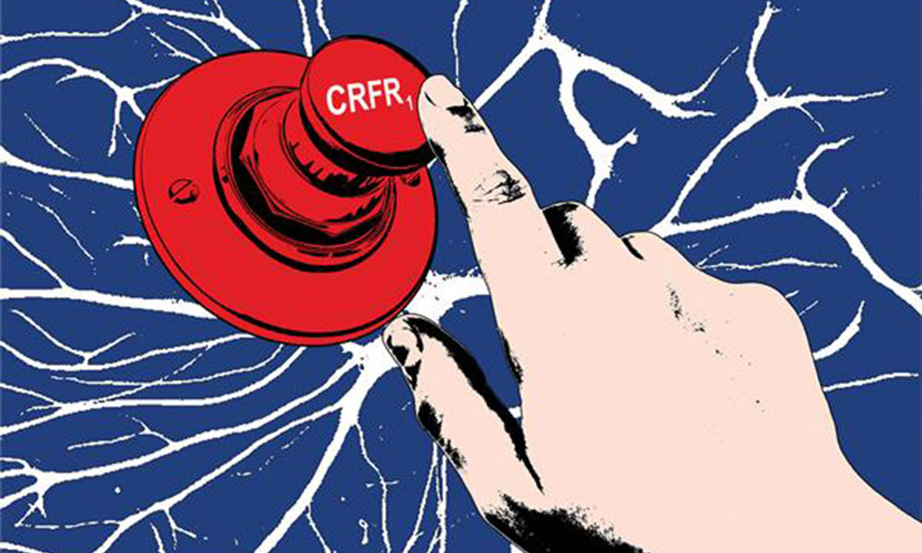](http://www.cell.com/cell-metabolism/fulltext/S1550-4131(16)30169-3)

**The role of CRFR1 receptor in stress response**

[Researchers at the Weizmann Institute of Science research](http://www.weizmann.ac.il/neurobiology/labs/chen/group-members) now show that neurons in the brain have an unexpected role to play in our body's reaction to stress. Previously, it was thought that the central nervous system, including the brain and spinal cord, was responsible for controlling the natural mechanisms in the body triggered by stress. [The findings published in *Cell Metabolism*](http://www.cell.com/cell-metabolism/fulltext/S1550-4131(16)30169-3)show that when stress hits, the cells in a certain area of the brain that function to balance energy (known as the CRFR1 receptor) have a surprising effect on nerve cells, activating the sympathetic nervous system.

The discovery of a linkage between the brain and the central nervous system in stress response could lead to developing treatments for people with eating disorders and other stress-induced illnesses that directly target the part of the brain where the energy-balancing neurons are, since drugs can enter the receptor in the brain with relative ease.

The study was conducted using lab mice. To continue investigating the CRFR1 receptor and its role in stress reaction, the researchers removed the CRFR1 receptor in lab mice, just from the cells that arouse appetite in the hypothalamus, the area of the brain that helps the body cope in stressful situations (and also contains the CRFR1 receptor). The researchers were then able to study and record how their bodies reacted to stressful situations. Surprisingly, female mice without the receptor reacted differently than male mice with the receptor to different stressors, including exposure to cold temperatures and food deprivation.

By studying how the receptor in the brain works and what role it plays in stressful situations, the study demonstrates that female and male bodies may react differently in stressful situations. The CRFR1 receptor's role in suppressing hunger may point to why women are more likely to develop eating disorders than men.